**Web Server Log Analysis Project Report**

1. **Abstract**: e-Commerce sites nowadays are contributing a lot towards big data. In order to find the interesting patterns or trends from this huge data, data scientists need to clean, integrate, aggregate and analyse the data. The purpose of this project is to find out trends by aggregating the data in such a networking site.
2. **Project objectives**: The core objective of the project is to understand the components and core technologies related to content retrieval, storage and data intensive analysis of large corpus of data collected over a specific period of time. Content Retrieval: The large amount of data is collected from Apache via eDvancer. Data Processing: Data collected over a period of time is processed by using parallel and distributed processing software framework developed by Apache Hadoop and using map reduce programming model. Storage: This data is stored in a certain format so as to form key value pair which is needed to feed to mapper in map-reduce programming approach. The data is stored in Hadoop Distributed File System. Data Analysis: The output obtained from reducer phase is analysed using data analysis
3. **Project Approach**: 1. Studying Hadoop architecture. 2. Configuring Hadoop system. 3. Understanding map reduce functionality. 4. Implementing log parser program in Map Reduce. 5. Understanding Pig Latin 6 Implementing Pig Latin for data analysis 7. Studying Apache weblog process workflow

**WorkFlow**



**4. Data**

Data format and source.

1. Data is collected from Apache web server.

2. Data is collected for different ranges of dates (day-range ,week-range)

3. Aggregated raw data is cleansed to some extend before analysing it using Map-Reduce methods. It is converted into structured format.

4. The format of collected logs has following fields:

Host

Identity

User

Date, Time and Time-zone

Request Line

Status code

Object size

Agent

Referrer URL

5. Each log is separated by new line and the above information is separated by a delimiter so that the processing in Map reduce is easy.



**5. Problem Statement**

1. Loading data into HDFS using **HDFS client.**

2. Developing **MR program** to parse logs and convert request string into structured Format (/a/b/c/d =>a b c d)

Developing **MR** program to extract data for the following KPIs.

3. Count of page views by individual user

4. Top / Bottom 5: catagery-1/ catagery-2 / page /users / entry pages

5. Total page views / Category wise pageviews / Unique pageviews

6. Count of status code = 200 / 404 / 400 / 500

7. Load results into tables in MySql Database using **Sqoop**.

Hadoop framework access a large semi structure data in a parallel computation model. Log files usually generated from the web server comprise of large volume of data that cannot be handled by a traditional database or other programming languages for computation. The proposed work aims on preprocessing the log file and keeps track on sessions accessed by the user, using Hadoop and the system architecture is shown in Fig. The work is divided into phases, where the storage and processing is made in HDFS.

**6) Solution Architecture :**

|  |
| --- |
| **Load data into HDFS** |
| |  | | --- | | **Process the data using Mapper function** | |
| **Load the preprocessed data into HDFS** |
| |  | | --- | | Analyse the data using Pig | |
| Export data into SQL |

**7. Software/Tools specification**

**Required Software**

Required software for Linux and Windows include:

1. JavaTM 1.6.x, preferably from Sun, must be installed.

2. **ssh** must be installed and running to use the Hadoop scripts that manage Hadoop daemons.

**Required Tools**

1. IDE – Eclipse

2. Mysql server

3.Pig

**Solution Description**:

1. **Load the file into HDFS**

hdfs dfs –mkdir –p Project/weblog

hdfs dfs –put /home/bansalshiv4329115/web.log Project/weblog/

hdfs dfs –cat Project/weblog/web.log

**Output**

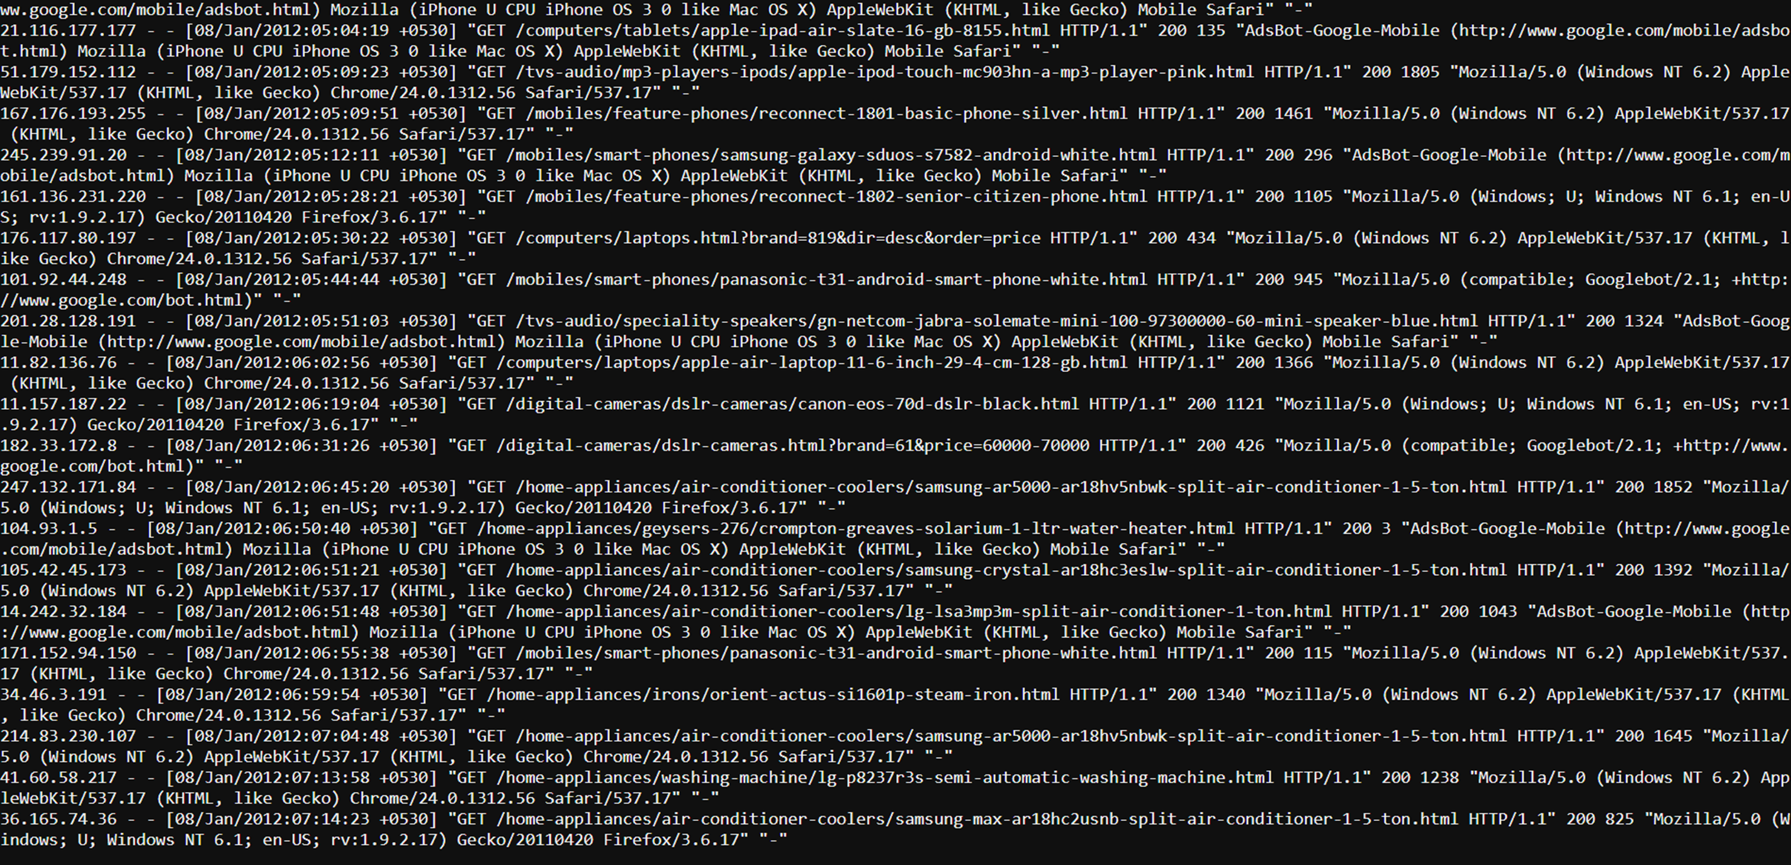

1. **Parse the log file into MapReduce**

**LogMapper.java**

import java.io.IOException;  
  
import org.apache.hadoop.io.IntWritable;  
import org.apache.hadoop.io.LongWritable;  
import org.apache.hadoop.io.NullWritable;  
import org.apache.hadoop.io.Text;  
import org.apache.hadoop.mapreduce.*;   
import java.util.regex.*;  
  
public class LogMapper extends Mapper<LongWritable, Text, NullWritable, Text>{  
      
    protected void map(LongWritable key, Text value, Context context) throws IOException, InterruptedException{  
        String ip,status_code, page,category1, category2;  
  
        String log = value.toString();  
        ip = getIpAddress(log);  
        page = getPage(log);  
        category1 = getCategory1(page);  
        category2 = getCategory2(page);  
        status_code = getStatusCode(log);  
        String final_string = ip+","+category1+","+category2+","+page+","+status_code;  
        context.write(NullWritable.get(),new Text(final_string));  
          
    }  
      
    protected String getIpAddress(String singlelog){  
        String IPADDRESS_PATTERN = "\\d{1,3}\\.\\d{1,3}\\.\\d{1,3}\\.\\d{1,3}";  
        Pattern pattern = Pattern.compile(IPADDRESS_PATTERN);  
        Matcher matcher = pattern.matcher(singlelog);  
        if (matcher.find()) {  
            return matcher.group();  
        } else{  
            return "0.0.0.0";  
        }  
          
          
    }  
      
    protected String getCategory1(String singlelog){  
          
        String CATEGORY1_PATTERN = "\\s/[^/^\\s]+";  
        Pattern pattern = Pattern.compile(CATEGORY1_PATTERN);  
        Matcher matcher = pattern.matcher(singlelog);  
        if (matcher.find()) {  
            return matcher.group().replaceAll("[/ ]","");  
        } else{  
            return "-";  
        }  
          
    }  
      
    protected String getCategory2(String singlelog){  
          
        String CATEGORY1_PATTERN = "\\s/[^/^\\s]+/[^/^\\s]+";  
        Pattern pattern = Pattern.compile(CATEGORY1_PATTERN);  
        Matcher matcher = pattern.matcher(singlelog);  
        if (matcher.find()) {  
            String singlelog1=matcher.group();  
            String CATEGORY1_PATTERN2 = "/[^/^\\s]+$";  
            Pattern pattern2 = Pattern.compile(CATEGORY1_PATTERN2);  
            Matcher matcher2 = pattern2.matcher(singlelog1);  
            if(matcher2.find()){  
                return matcher2.group().replaceAll("[/ ]","");  
                  
            }else{  
                return "-";  
            }  
        } else{  
            return "-";  
        }  
          
    }  
    protected String getStatusCode(String singlelog){  
          
        String CODE_PATTERN = "\"\\s\\d{3}\\s";  
        Pattern pattern = Pattern.compile(CODE_PATTERN);  
        Matcher matcher = pattern.matcher(singlelog);  
        if (matcher.find()) {  
            return matcher.group().replaceAll("[\" ]","");  
        } else{  
            return "-";  
        }  
          
    }  
    protected String getPage(String singlelog){  
        String PAGE_PATTERN = "\\s(/[^/^\\s]+)+\\s";  
        Pattern pattern = Pattern.compile(PAGE_PATTERN);  
        Matcher matcher = pattern.matcher(singlelog);  
        if (matcher.find()) {  
            return matcher.group();  
        } else{  
            return "-";  
        }  
          
    }  
}

**LogDriver.java**

import org.apache.hadoop.fs.Path;   
import org.apache.hadoop.conf.*;  
import org.apache.hadoop.mapreduce.Job;  
import org.apache.hadoop.mapreduce.lib.input.FileInputFormat;   
import org.apache.hadoop.mapreduce.lib.input.TextInputFormat;   
import org.apache.hadoop.mapreduce.lib.output.FileOutputFormat;   
import org.apache.hadoop.mapreduce.lib.output.TextOutputFormat;  
import org.apache.hadoop.io.IntWritable;  
import org.apache.hadoop.io.NullWritable;  
import org.apache.hadoop.io.Text;  
  
public class LogDriver {  
    @SuppressWarnings("deprecation")  
    public static void main(String[] args) throws Exception {  
        Configuration conf = new Configuration();  
        Job job = new Job(conf, "DemoTask1");  
        job.setJarByClass(LogDriver.class);  
  
          
        job.setNumReduceTasks(0);  
        job.setMapOutputKeyClass(NullWritable.class);  
        job.setMapOutputValueClass(Text.class);  
          
        job.setOutputValueClass(Text.class);  
        job.setOutputKeyClass(NullWritable.class);  
        job.setMapperClass(LogMapper.class);  
  
          
           
        job.setInputFormatClass(TextInputFormat.class);  
        job.setOutputFormatClass(TextOutputFormat.class);  
  
        FileInputFormat.addInputPath(job, new Path(args[0]));   
        FileOutputFormat.setOutputPath(job,new Path(args[1]));  
          
        /*  
        Path out=new Path(args[1]);  
        out.getFileSystem(conf).delete(out);  
        */  
          
        job.waitForCompletion(true);  
    }  
}

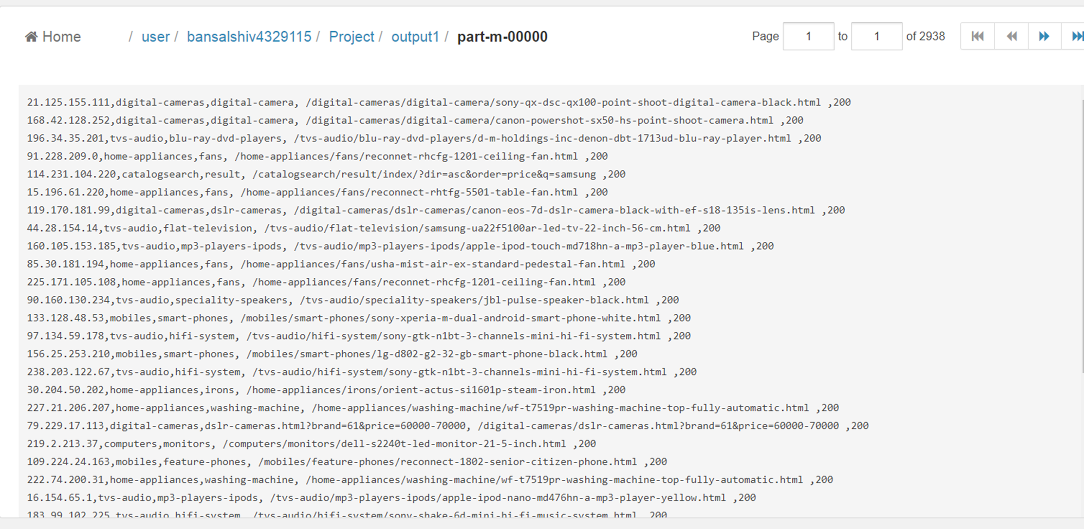

**3 Count of page views by individual user**

input1 = Load 'Project/output1' Using PigStorage(',') AS (ipaddress:chararray,category1:chararray,category2:chararray,page:chararray,status:int) ;

group_data = Group input1 by ipaddress;

count_data = Foreach group_data Generate($0),COUNT(A.ipaddress);

STORE count_data INTO 'Project/output3’ ;

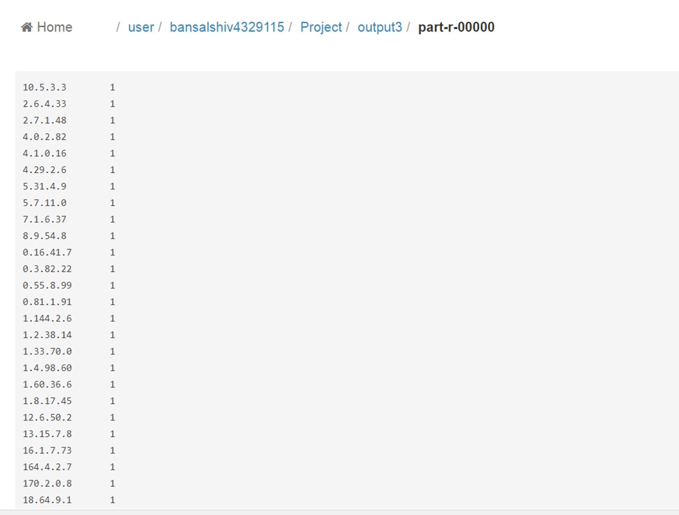

4(a**) TOP 5 Category1**

input1 = Load 'Project/output1' Using PigStorage(',') AS (ipaddress:chararray,category1:chararray,category2:chararray,page:chararray,status:int) ;

filter_data = Filter input1 by status ==200 AND (page!='*.css');

group_data = Group filter_data by category1;

count_data = Foreach group_data Generate($0),COUNT(filter_data.page)as views;

order_data = Order count_data By views DESC ;

limit_data = Limit order_data 5;

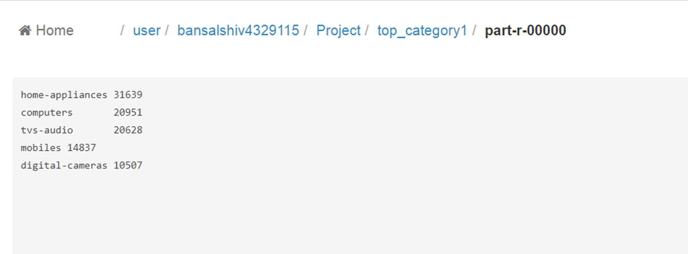

(b) **Bottom 5 category1**

input1 = Load 'Project/output1' Using PigStorage(',') AS (ipaddress:chararray,category1:chararray,category2:chararray,page:chararray,status:int) ;

filter_data = Filter input1 by status ==200 AND (page!='*.css');

group_data = Group filter_data by category1;

count_data = Foreach group_data Generate($0),COUNT(filter_data.page)as views;

order_data = Order count_data By views ASC ;

limit_data = Limit order_data 5;

STORE limit_data INTO 'Project/bottom_category1';

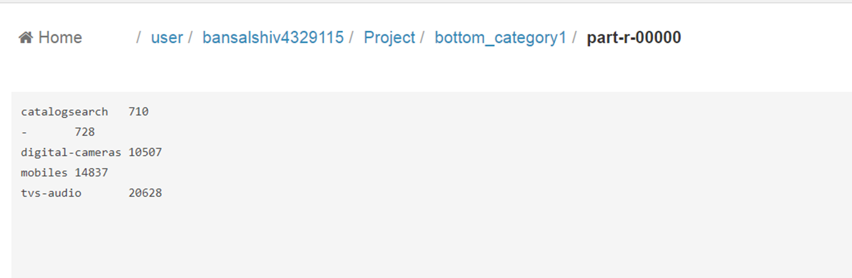

(c) **TOP 5 Category2**

input1 = Load 'Project/output1' Using PigStorage(',') AS (ipaddress:chararray,category1:chararray,category2:chararray,page:chararray,status:int) ;

filter_data = Filter input1 by status ==200 AND (page!='*.css');

group_data = Group filter_data by category2;

count_data = Foreach group_data Generate($0),COUNT(filter_data.page)as views;

order_data = Order count_data By views DESC ;

limit_data = Limit order_data 5;

STORE limit_data INTO 'Project/top_category2';

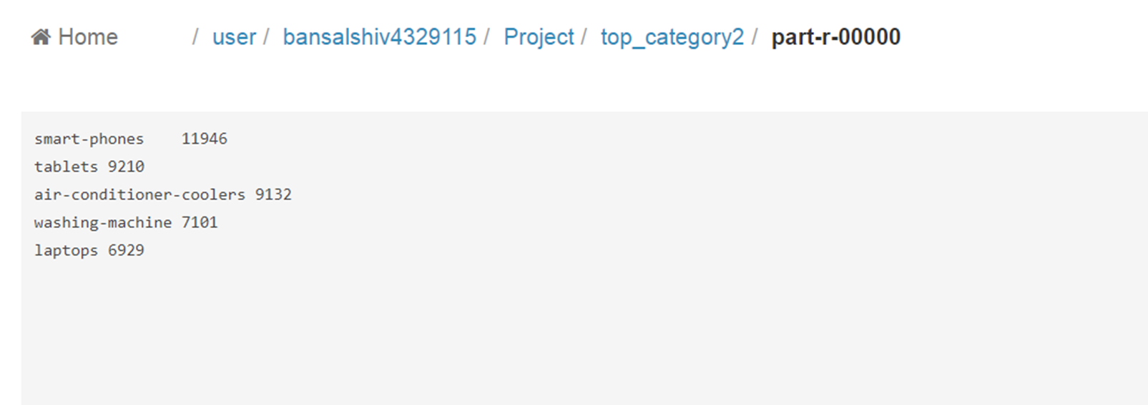

(d) **Bottom 5 Categoty2**

input1 = Load 'Project/output1' Using PigStorage(',') AS (ipaddress:chararray,category1:chararray,category2:chararray,page:chararray,status:int) ;

filter_data = Filter input1 by status ==200 AND (page!='*.css');

group_data = Group filter_data by category2;

count_data = Foreach group_data Generate($0),COUNT(filter_data.page)as views;

order_data = Order count_data By views ASC ;

limit_data = Limit order_data 5;

STORE limit_data INTO 'Project/bottom_category2';

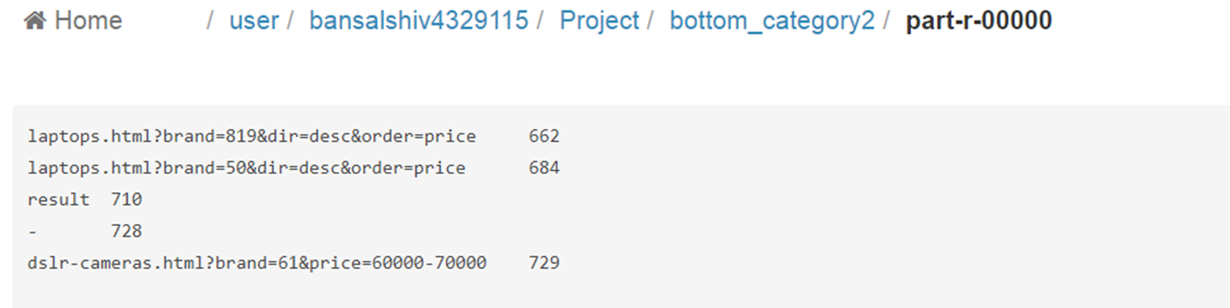

(e) **TOP 5 Page**

input1 = Load 'Project/output1' Using PigStorage(',') AS (ipaddress:chararray,category1:chararray,category2:chararray,page:chararray,status:int) ;

filter_data = Filter input1 by status ==200 AND (page!='*.css');

group_data = Group filter_data by page;

count_data = Foreach group_data Generate($0),COUNT(filter_data.page)as views;

order_data = Order count_data By views DESC ;

limit_data = Limit order_data 5;

STORE limit_data INTO 'Project/top_page’ ;

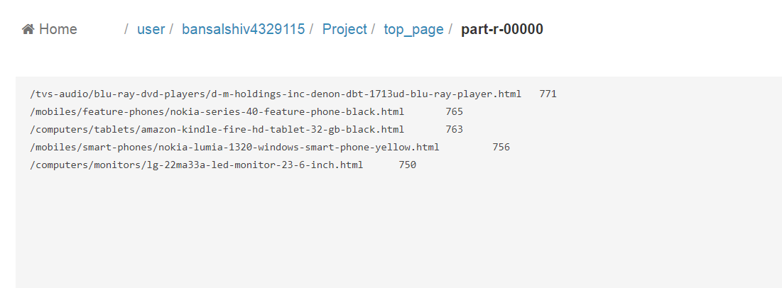

(f**) Bottom 5 Page**

input1 = Load 'Project/output1' Using PigStorage(',') AS (ipaddress:chararray,category1:chararray,category2:chararray,page:chararray,status:int) ;

filter_data = Filter input1 by status ==200 AND (page!='*.css');

group_data = Group filter_data by page;

count_data = Foreach group_data Generate($0),COUNT(filter_data.page)as views;

order_data = Order count_data By views ASC ;

limit_data = Limit order_data 5;

STORE limit_data INTO 'Project/bottom_page’ ;

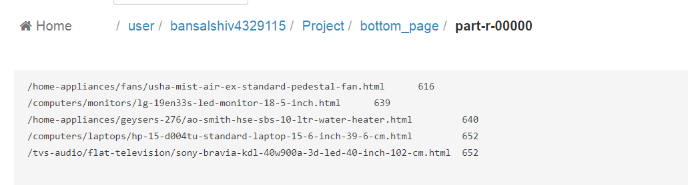

(g) **Top 5 user**

input1 = Load 'Project/output1' Using PigStorage(',') AS (ipaddress:chararray,category1:chararray,category2:chararray,page:chararray,status:int) ;

filter_data = Filter input1 by status ==200 AND (page!='*.css');

group_data = Group filter_data by ipaddress;

count_data = Foreach group_data Generate($0),COUNT(filter_data.page)as views;

order_data = Order count_data By views DESC ;

limit_data = Limit order_data 5;

STORE limit_data INTO 'Project/top_user';

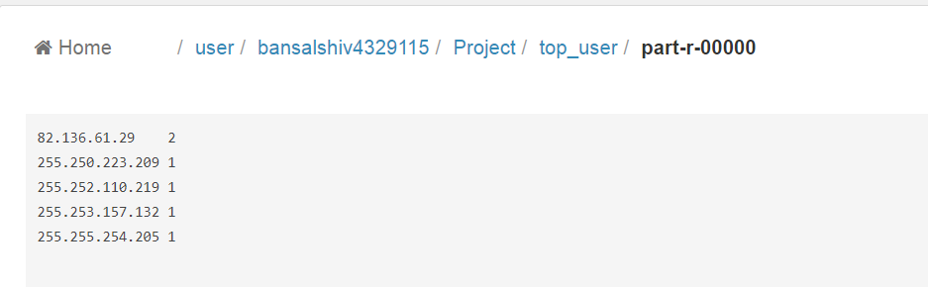

(h) **Bottom 5 User**

input1 = Load 'Project/output1' Using PigStorage(',') AS (ipaddress:chararray,category1:chararray,category2:chararray,page:chararray,status:int) ;

filter_data = Filter input1 by status ==200 AND (page!='*.css');

group_data = Group filter_data by ipaddress;

count_data = Foreach group_data Generate($0),COUNT(filter_data.page)as views;

order_data = Order count_data By views ASC ;

limit_data = Limit order_data 5;

STORE limit_data INTO 'Project/bottom_user';

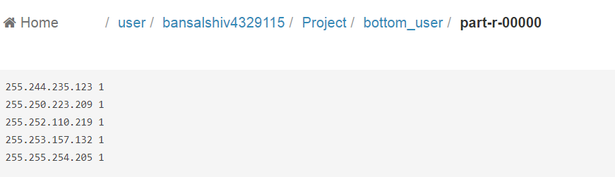

**5(a) Total Page**

input1 = Load 'Project/output1' Using PigStorage(',') AS (ipaddress:chararray,category1:chararray,category2:chararray,page:chararray,status:int) ;

group_data = Group input1 by page;

count_data = Foreach group_data Generate($0),COUNT(input1.page)as views;

STORE count_data INTO 'Project/totalpage';

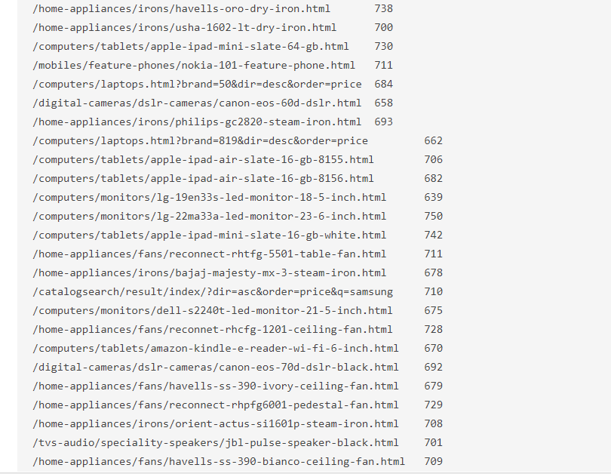

**(b) Total category view**

input1 = Load 'Project/output1' Using PigStorage(',') AS (ipaddress:chararray,category1:chararray,category2:chararray,page:chararray,status:int) ;

concat_data= FOREACH input1 GENERATE (ipaddress),CONCAT(category1,category2) as Category;

group_data = Group concat_data by Category;

count_data = Foreach group_data Generate ($0),COUNT(concat_data.Category);

STORE count_data INTO 'Project/category_data' ;

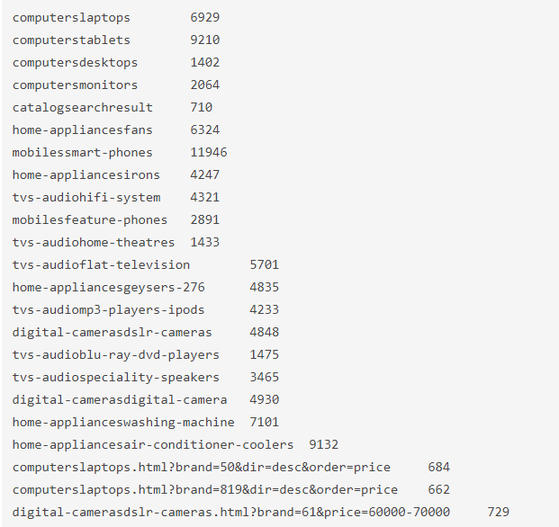

**(c ) UniqueView**

input1 = Load 'Project/output1' Using PigStorage(',') AS (ipaddress:chararray,category1:chararray,category2:chararray,page:chararray,status:int) ;

group_data = Group input1 by page;

count_data = FOREACH group_data{

data1 = input1.ipaddress;

distinct_data = DISTINCT data1;

GENERATE group,COUNT(distinct_data);

}

STORE count_data INTO 'Project/uniqueview' ;

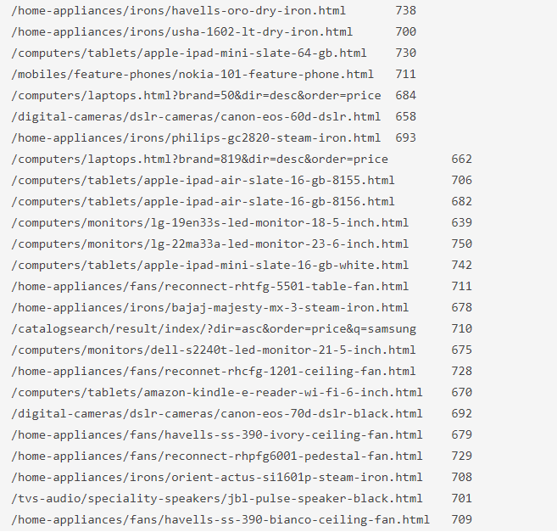

**6 Status**

6 input1 = Load 'Project/output1' Using PigStorage(',') AS (ipaddress:chararray,category1:chararray,category2:chararray,page:chararray,status:int) ;

filter_data = Filter input1 by (status== 400) OR(status==404) OR(status==200) OR(status==500) ;

groupd_data = Group filter_data by status;

count_data= Foreach groupd_data Generate($0),COUNT(filter_data.ipaddress);

STORE count_data INTO 'Project/status_data' ;

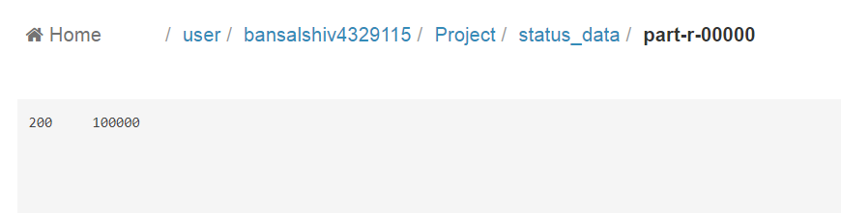

&**7 Export Data into tables using sqoop**

sqoop export --connect jdbc:mysql://ip-172-31-13-154/retail_db --table number_user1 --export-dir /user/bansalshiv4329115/Project/output3 --username sqoopuser -P --fields-terminated-by '\t' -m1

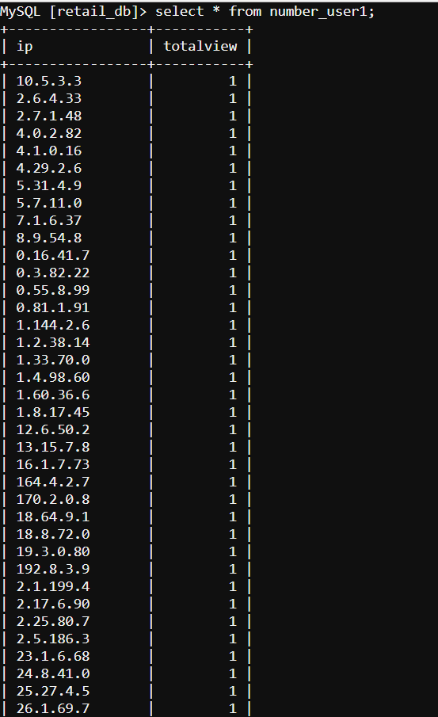

(b)

sqoop export --connect jdbc:mysql://ip-172-31-13-154/sqoopex --table bottom_category1 --export-dir /user/bansalshiv4329115/Project/bottom_category1 --username sqoopuser -P --fields-terminated-by '\t' -m1

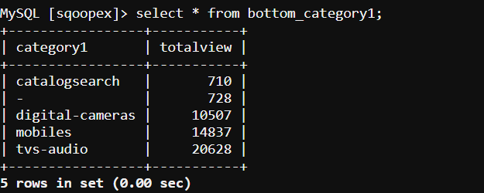

sqoop export --connect jdbc:mysql://ip-172-31-13-154/sqoopex --table bottom_category2 --export-dir /user/bansalshiv4329115/Project/bottom_category2 --username sqoopuser -P --fields-terminated-by '\t' -m1

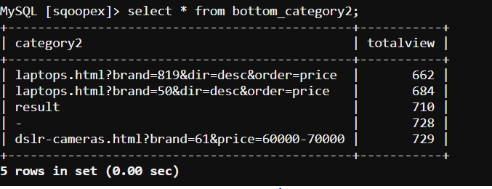

sqoop export --connect jdbc:mysql://ip-172-31-13-154/sqoopex --table top_category1 --export-dir /user/bansalshiv4329115/Project/top_category1 --username sqoopuser -P --fields-terminated-by '\t' -m1

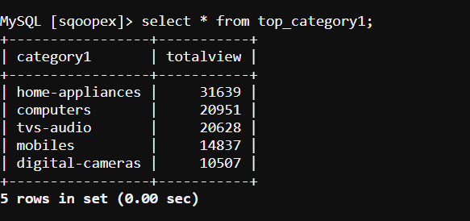

sqoop export --connect jdbc:mysql://ip-172-31-13-154/sqoopex --table top_category2 --export-dir /user/bansalshiv4329115/Project/top_category2 --username sqoopuser -P --fields-terminated-by '\t' -m1

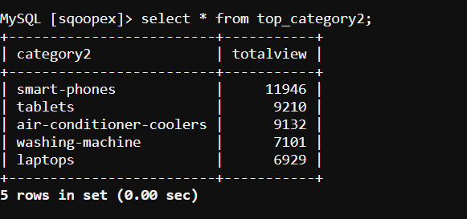

sqoop export --connect jdbc:mysql://ip-172-31-13-154/sqoopex --table totalpage --export-dir /user/bansalshiv4329115/Project/totalpage --username sqoopuser -P --fields-terminated-by '\t' -m1

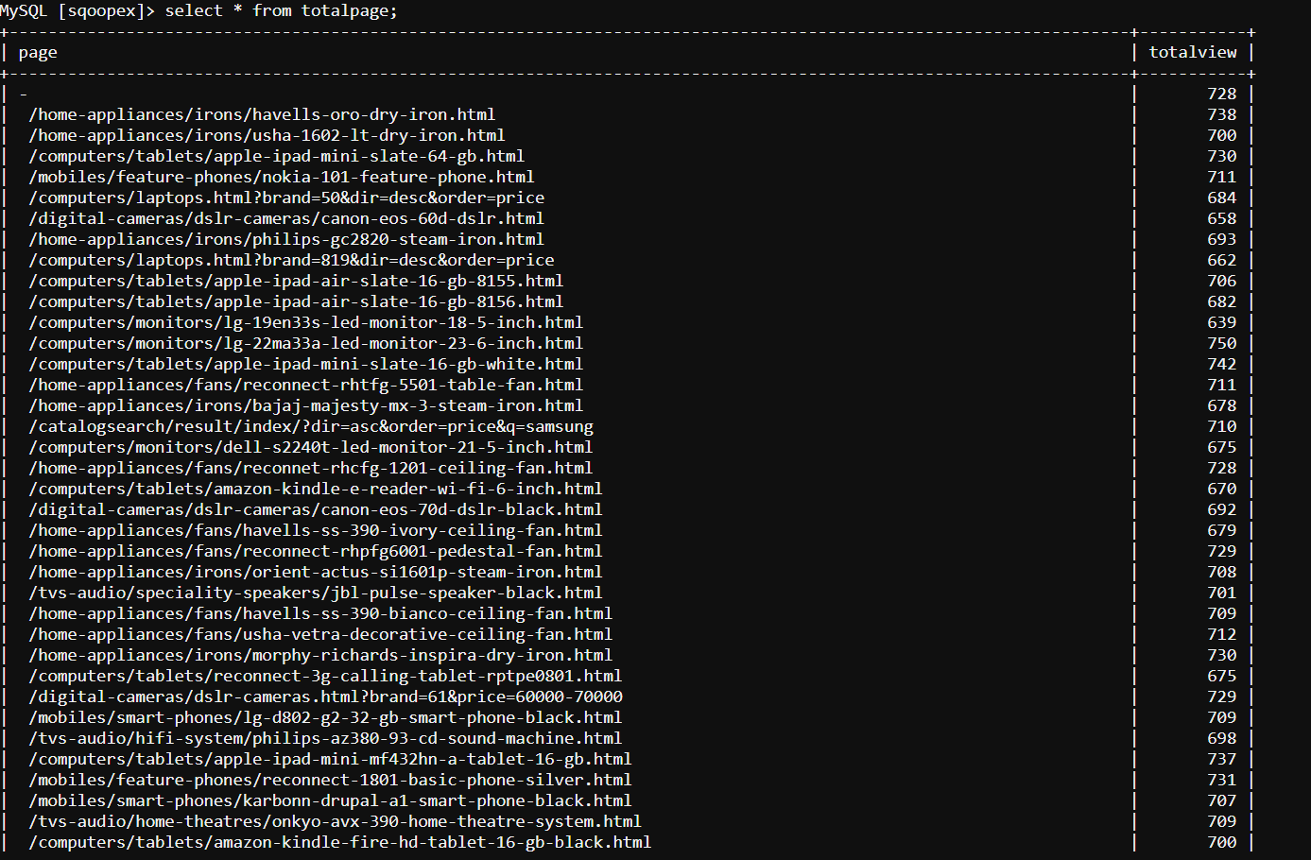

sqoop export --connect jdbc:mysql://ip-172-31-13-154/sqoopex --table uniqueview --export-dir /user/bansalshiv4329115/Project/uniqueview --username sqoopuser -P --fields-terminated-by '\t' -m1

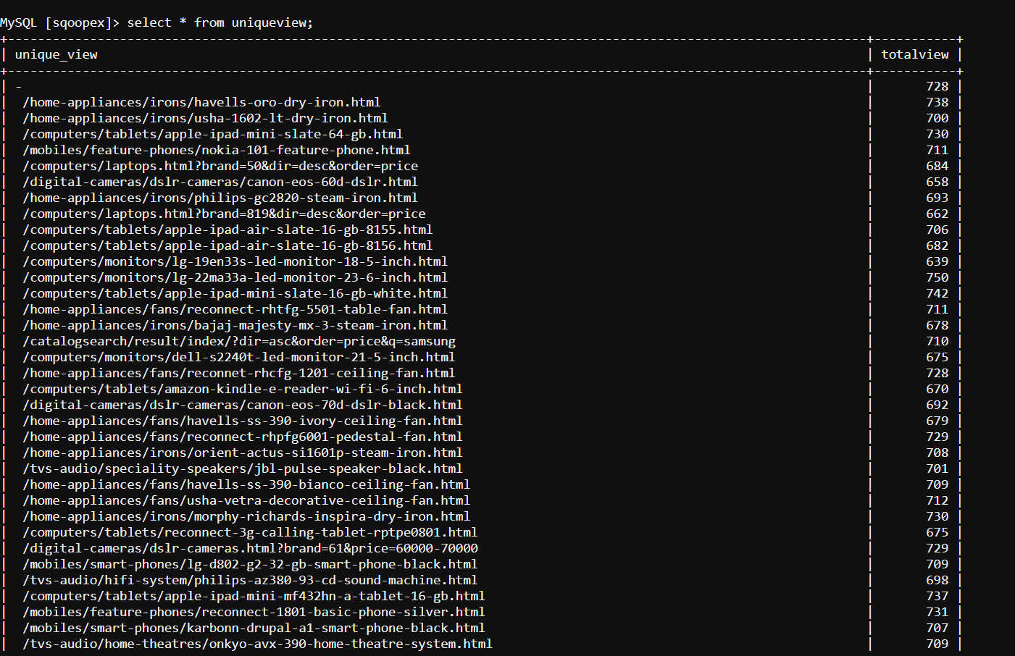

sqoop export --connect jdbc:mysql://ip-172-31-13-154/sqoopex --table status_data --export-dir /user/bansalshiv4329115/Project/status_data --username sqoopuser -P --fields-terminated-by '\t' -m1

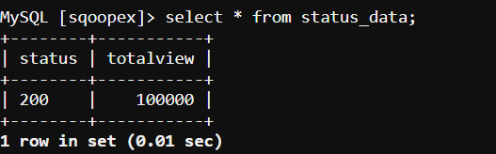

sqoop export --connect jdbc:mysql://ip-172-31-13-154/sqoopex --table category_data --export-dir /user/bansalshiv4329115/Project/category_data --username sqoopuser -P --fields-terminated-by '\t' -m1

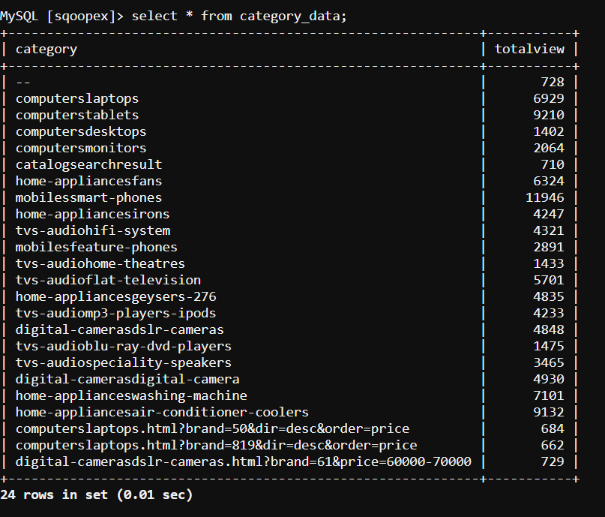

sqoop export --connect jdbc:mysql://ip-172-31-13-154/sqoopex --table bottom_user --export-dir /user/bansalshiv4329115/Project/bottom_user --username sqoopuser -P --fields-terminated-by '\t' -m1

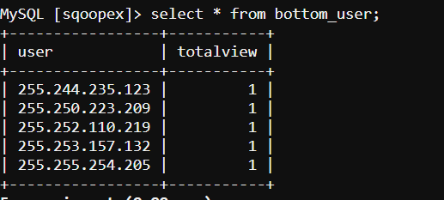

sqoop export --connect jdbc:mysql://ip-172-31-13-154/sqoopex --table top_user --export-dir /user/bansalshiv4329115/Project/top_user --username sqoopuser -P --fields-terminated-by '\t' -m1

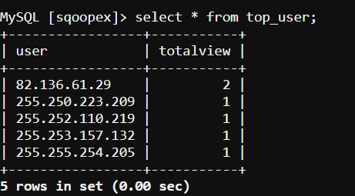

sqoop export --connect jdbc:mysql://ip-172-31-13-154/sqoopex --table bottom_page --export-dir /user/bansalshiv4329115/Project/bottom_page --username sqoopuser -P --fields-terminated-by '\t' -m1

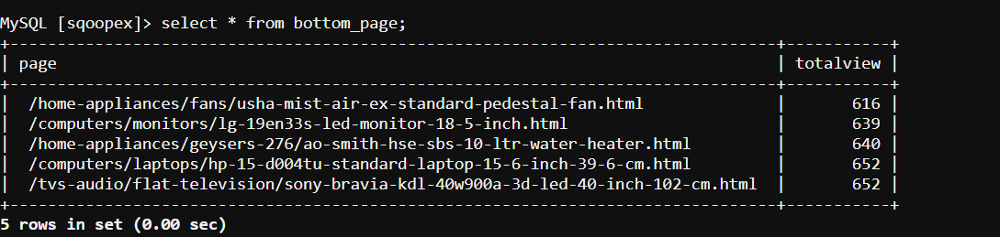

sqoop export --connect jdbc:mysql://ip-172-31-13-154/sqoopex --table top_page --export-dir /user/bansalshiv4329115/Project/top_page --username sqoopuser -P --fields-terminated-by '\t' -m1

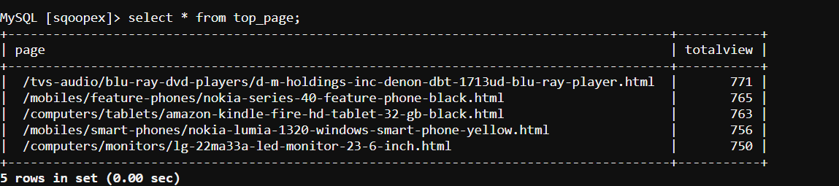

**CONCLUSION**

At present the Big data technology is successfully incorporated for all real domain problems such as web log analysis, fraud detection and text analysis. This project supports the importance of one of the Big data technology Hadoop, where the framework handles large amount of data in a cluster for web log mining. Data cleaning, the main part of preprocessing is performed to remove the inconsistent data. The preprocessed data is again manipulated using session identification algorithm to explore the user session. Unique identification of fields is carried out to track the user behaviour. The huge data is stored in HDFS as text files and is accessed around the cluster in blocks. From the results it is observed that the framework developed in hadoop has high performance when compared to the other approaches.